**We presented our project to people at NATM:**

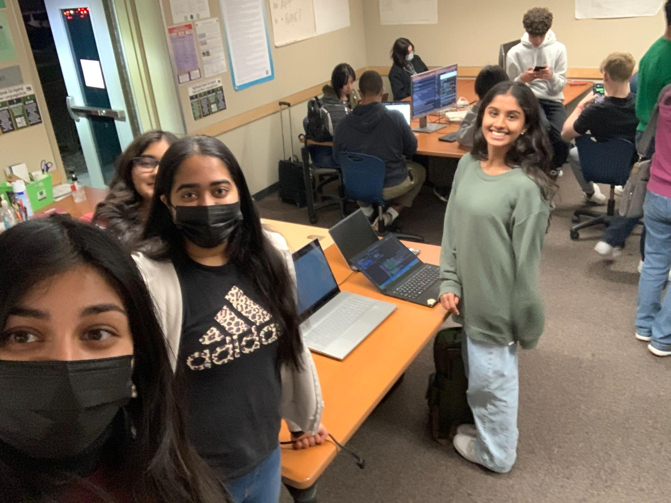

Many people came up to our laptop display and inquired about our project. Some included parents, who saw a practical use to our recipe organizer and appreciated the usefulness of an ingredient nutritional value checker, meal planner, and recipe finder.

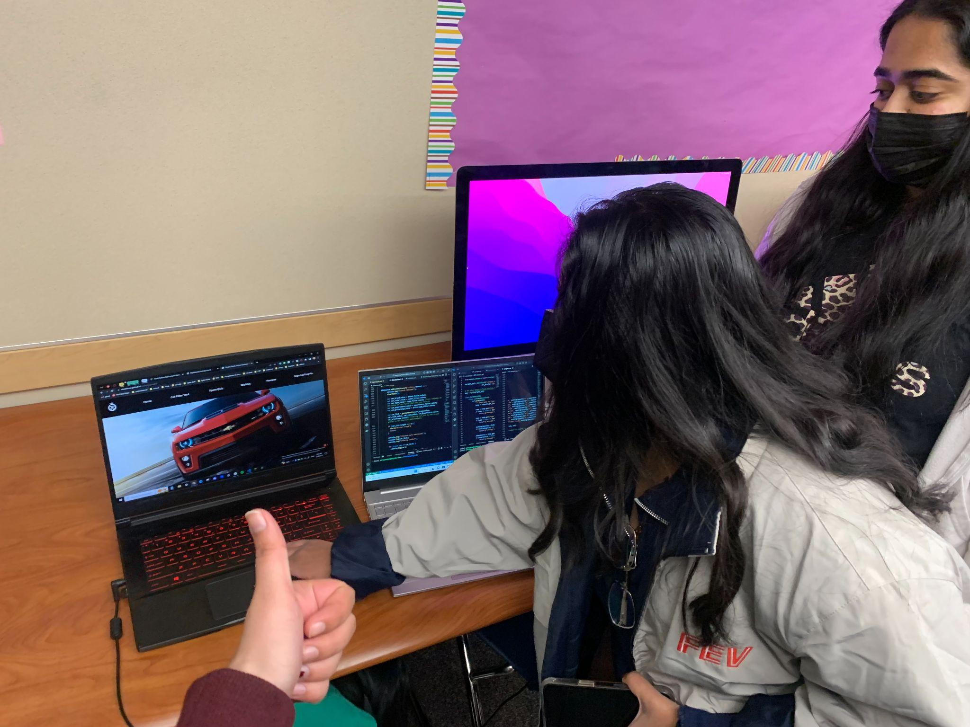

We observed other groups’ projects, including the ones pictured above related to cars. This group included a cars search feature, which I thought was similar to the recipe search feature I used. I think our backends were aiming to accomplish the same task, which was to take user inputs/ specifications, and output something that met those requirements.

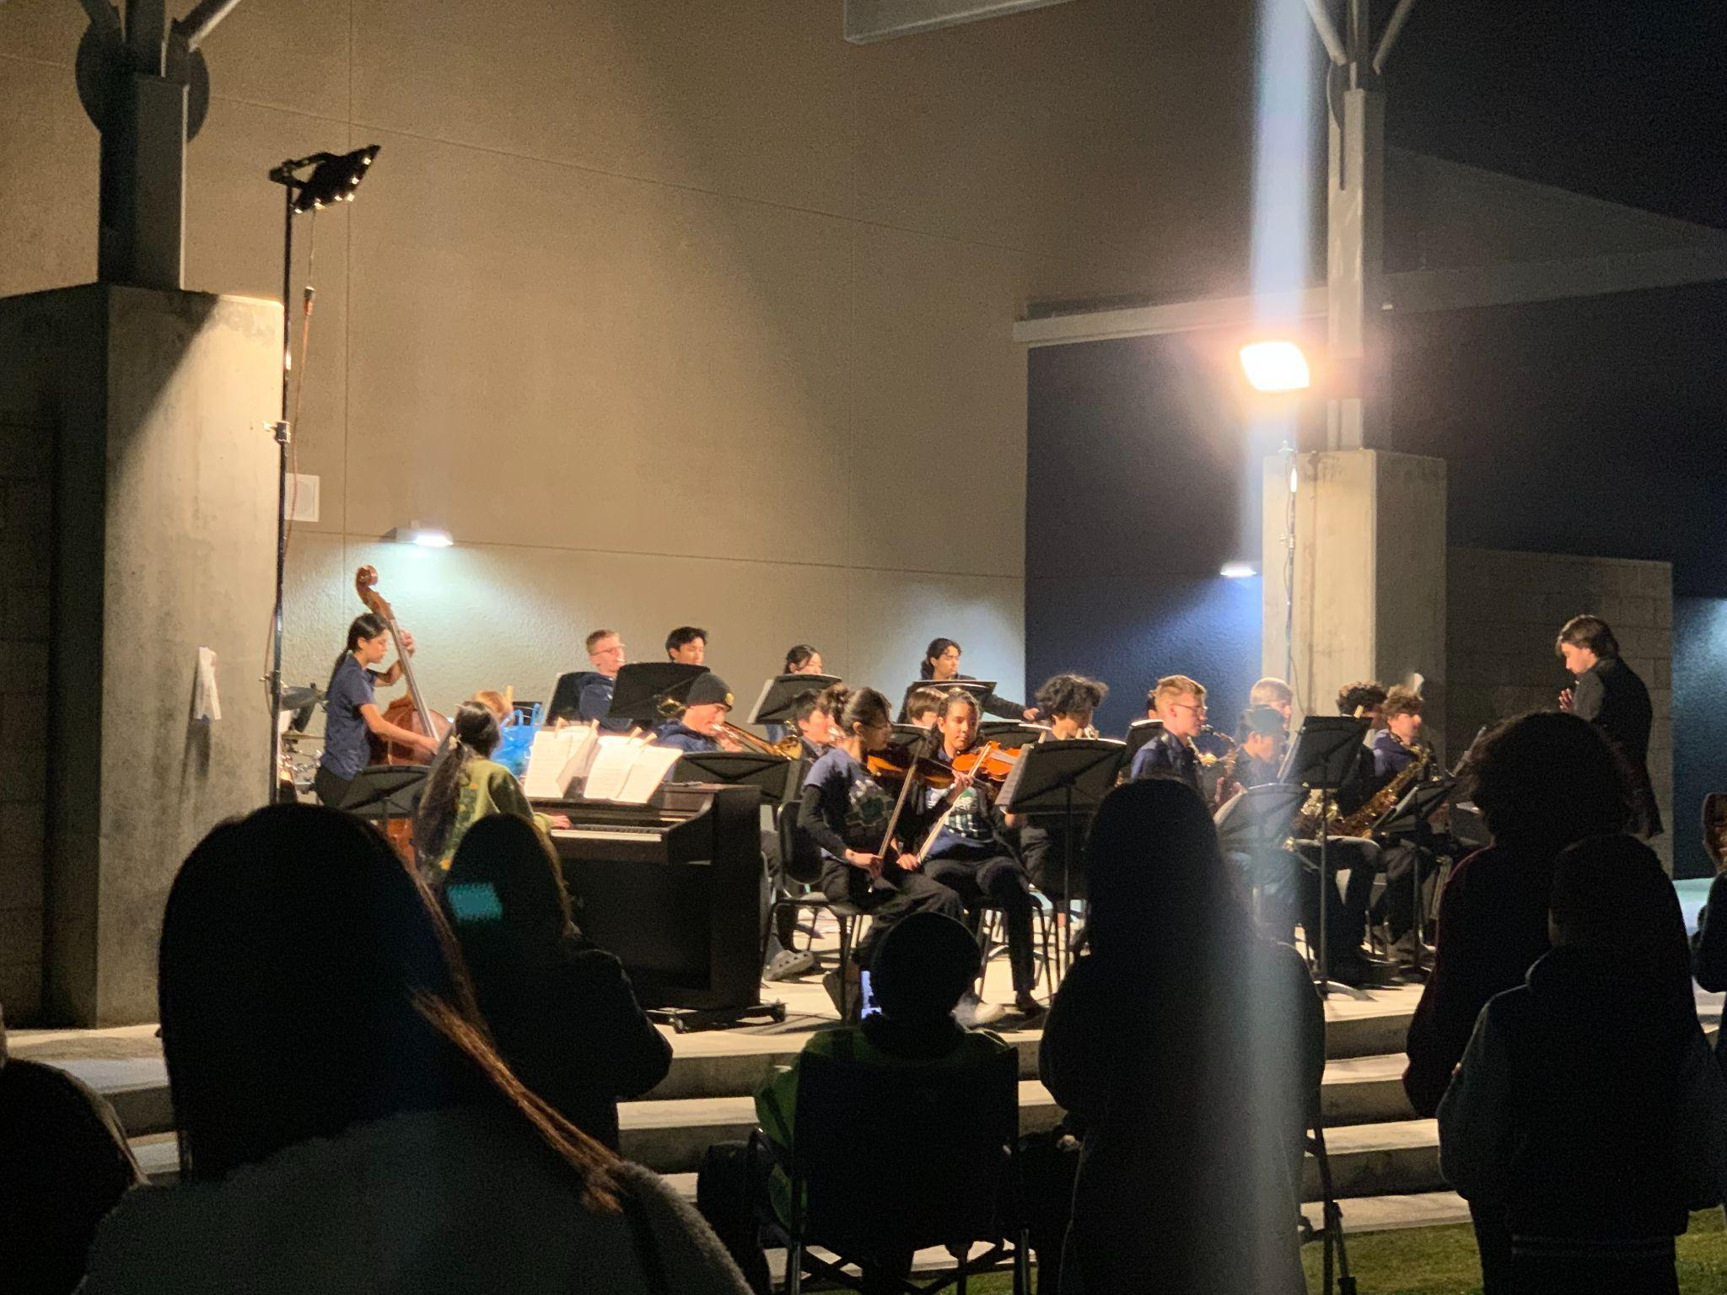

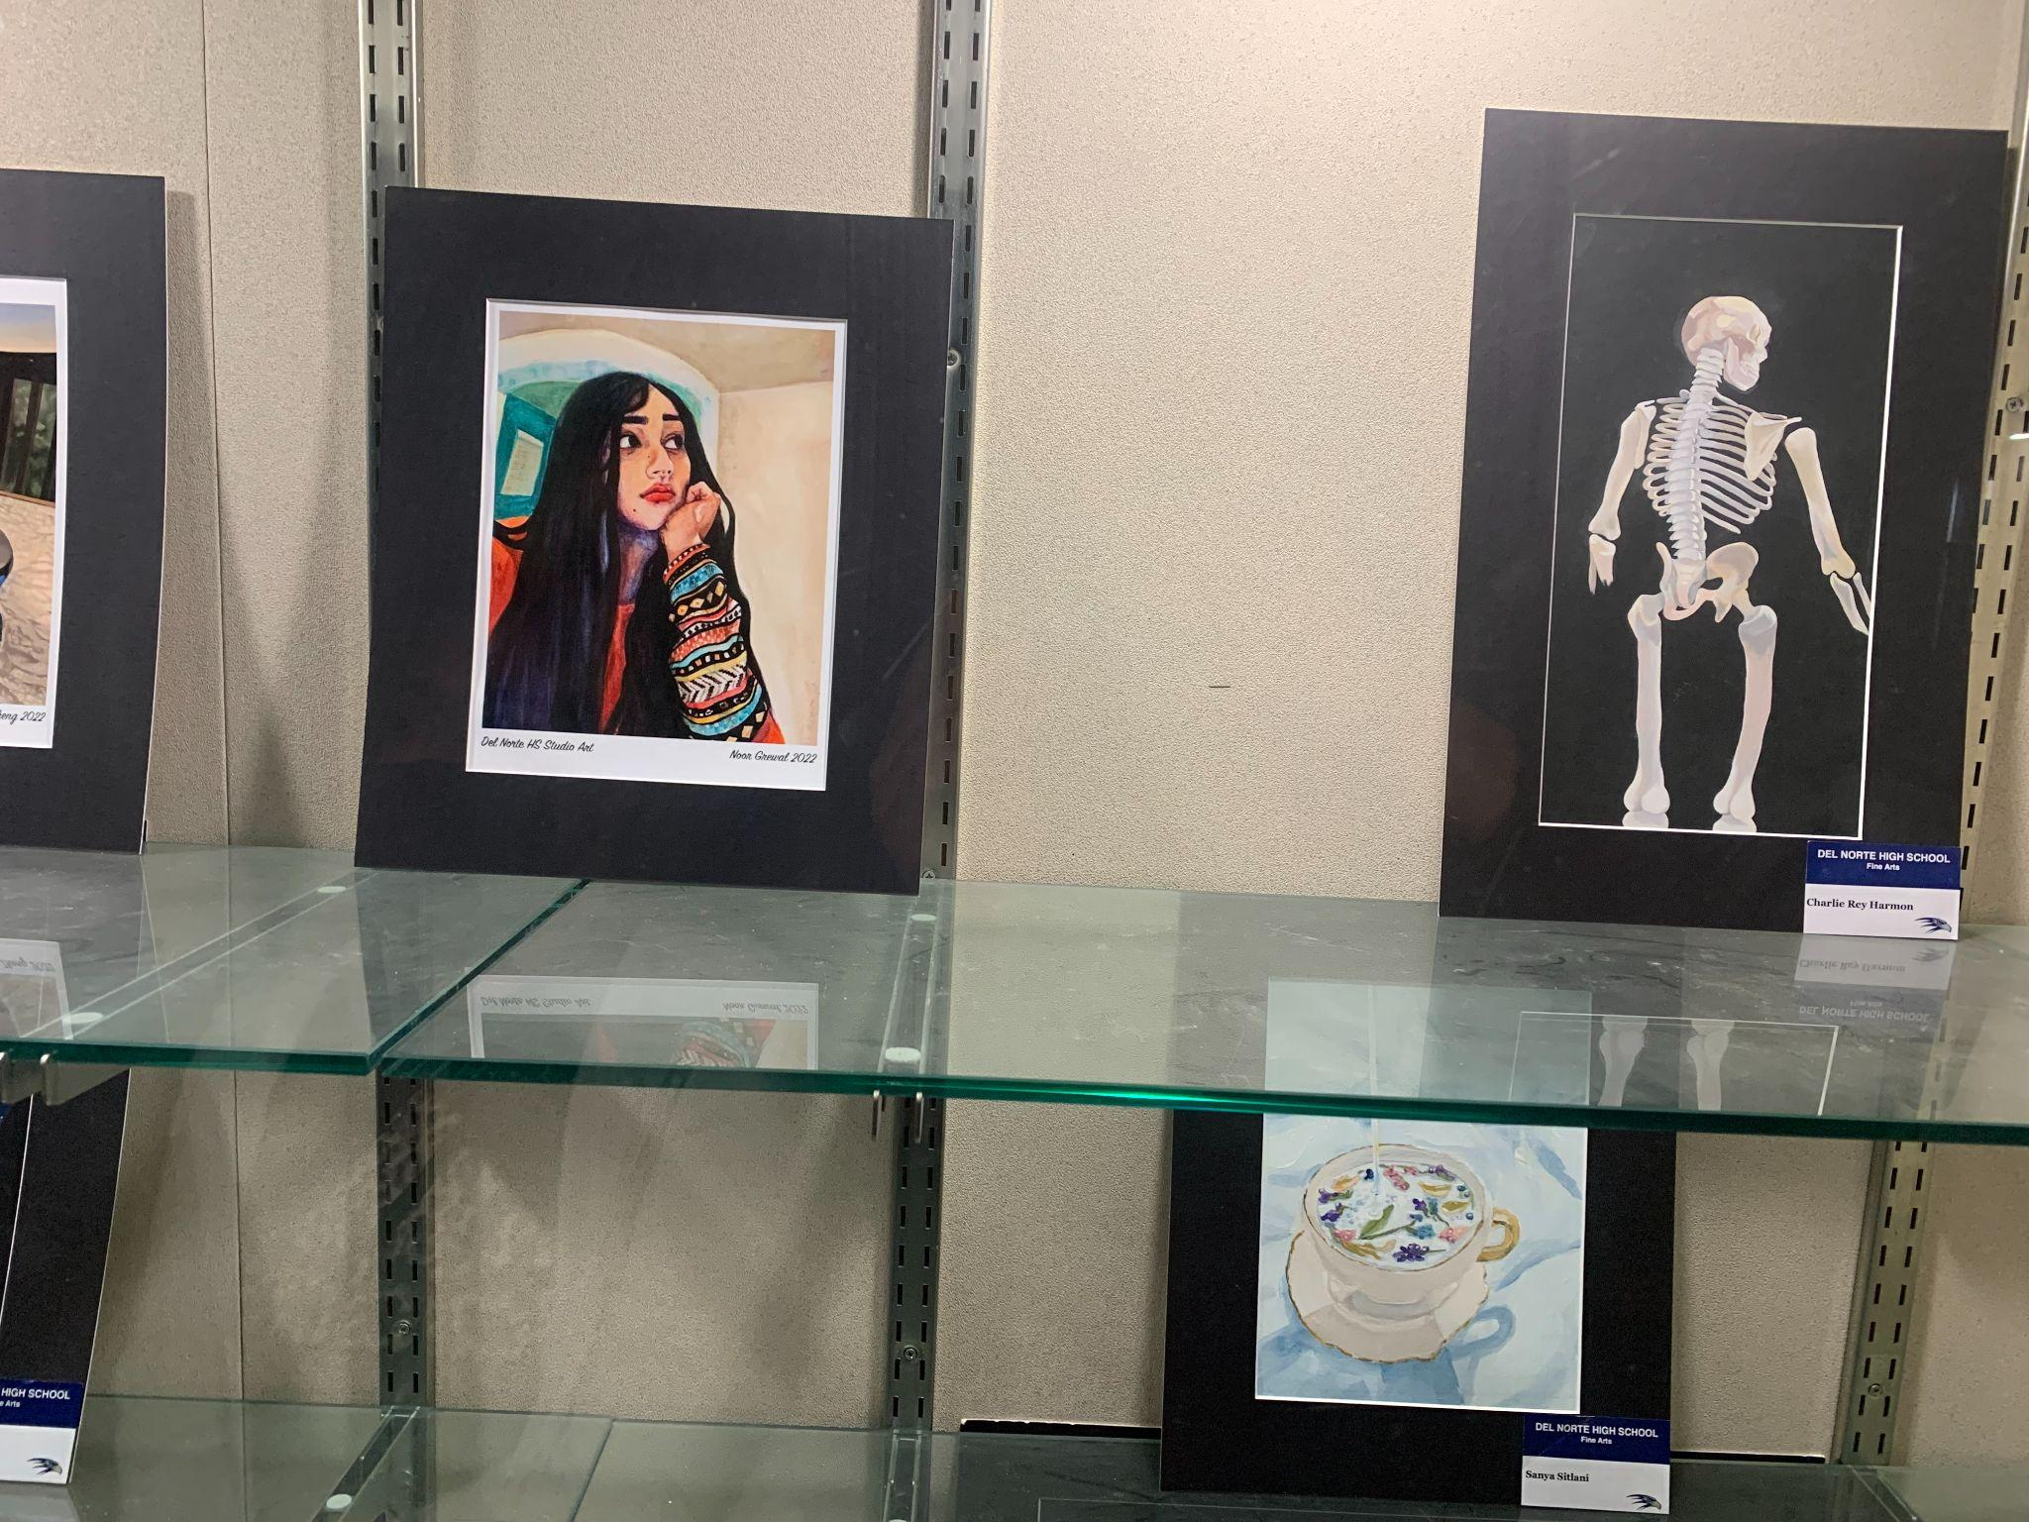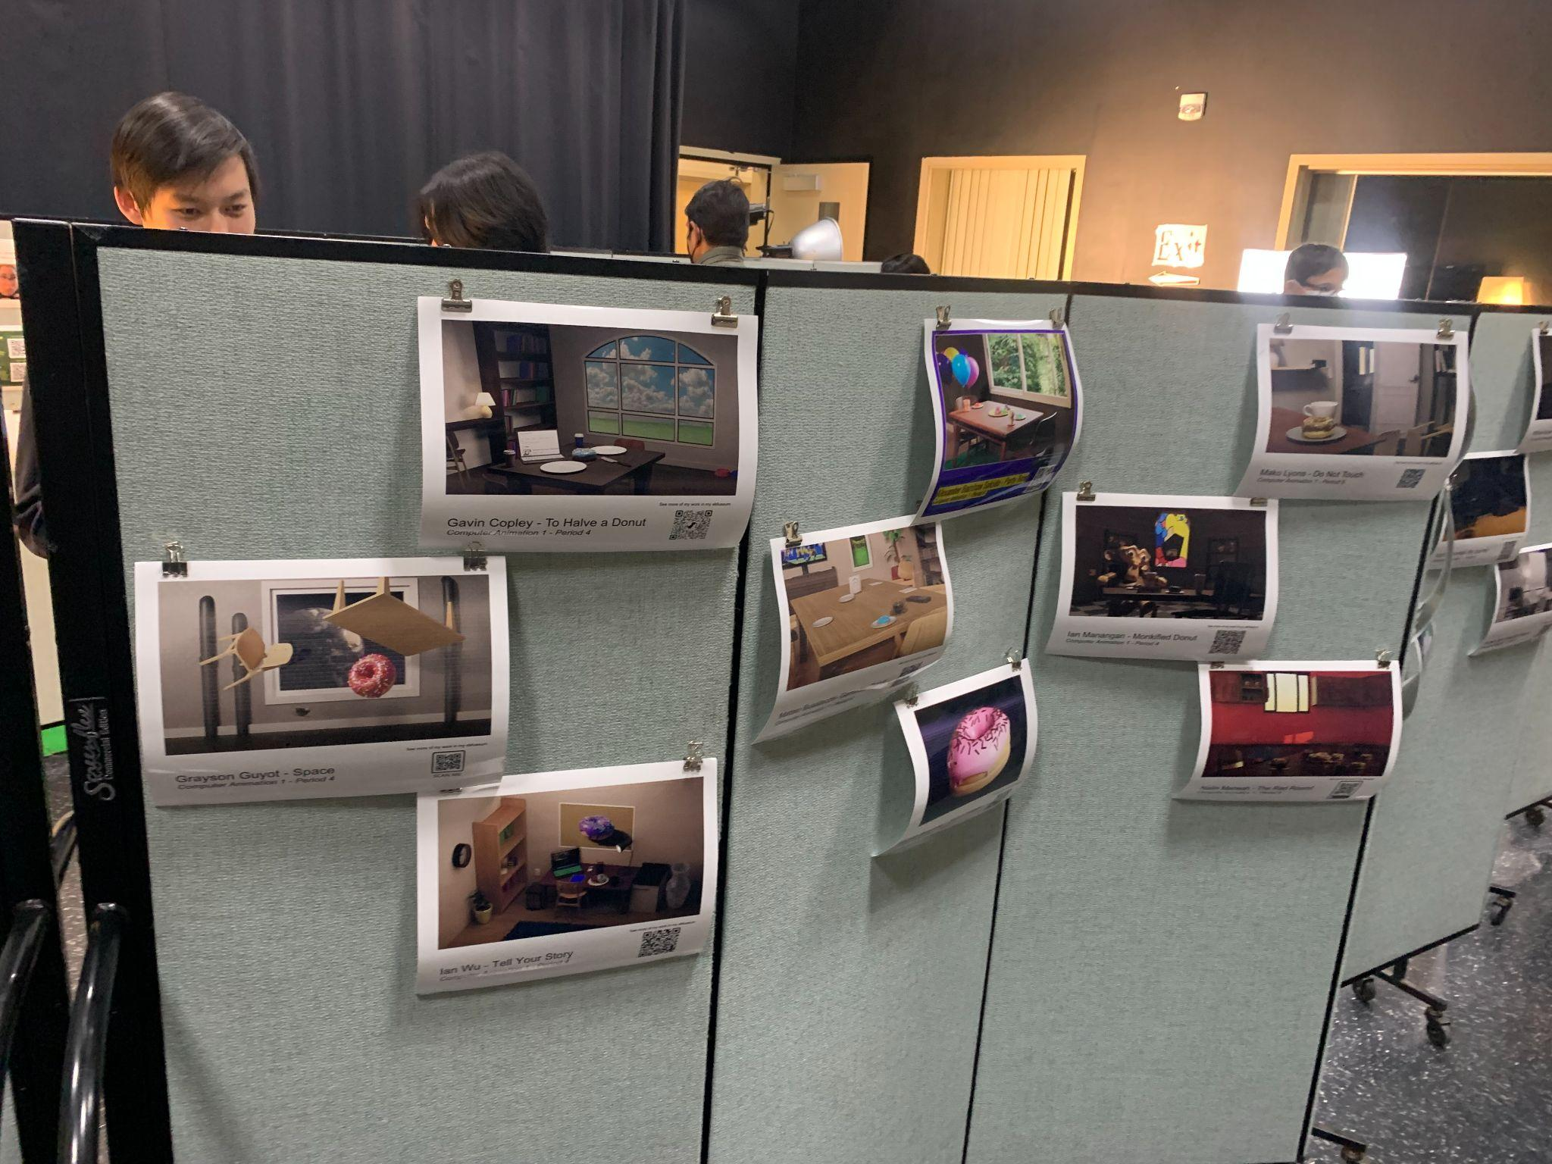

I also watched the jazz performers, who played beautifully, and other fine arts displays. These were a reminder that even though computer technology is very useful and helpful for tasks, authentic artwork is unique to the human experience and can’t be perfectly replicated.